Is TAC Management a Source of Bias for Stock Assessment Models?
Daniel Goethel
Background: Stock assessment models are based on the concept that the ‘virtual population’ can be recreated/estimated from relatively well known catch and auxiliary information (index timeseries, stock-recruit function). Originally, VPAs were used that assumed catch-at-age was known without error and, thus, formed a known portion of the virtual population (i.e., from known catch the remaining ‘virtual’ segment of the population could be recreated). VPA methods work well when F is high, because the known segment of the population is large (i.e., high F leads to large catches, which reduces the ratio of virtual to known population from which the model must begin recreating the total population). Statistical catch-at-age models have seen a rise over the last two decades for a variety of reasons, but mainly because they can better handle uncertainty in catch data and are more flexible and better equipped to handle alternate data sources compared to VPA models. As fishing effort in developed nations has become better controlled, SCAAs have become more popular partially because they do not rely on the catch being known exactly. As fishing effort is limited and catch quotas become more restrictive, there may be a higher tendency for misreporting catch or underreporting bycatch by fishermen. SCAA are able to deal with uncertain catch by allowing an error distribution around observed catch values. Despite the increased reliance on SCAA models, little research has been conducted into their performance when fishing effort is low or TACs are restrictive. In the case of VPA models, it has been well established that model performance declines at low fishing mortality and catch levels. It is widely assumed that because SCAA models are more flexible and project forward from estimates of recruitment (instead of back calculating from a known catch), that they can better handle scenarios where catches are low.
However, regardless of assessment method, a model can only be as reliable as the data itself. SCAA models are still heavily reliant on catch data to scale abundance estimates. Although SCAA models rely on auxiliary data such as indices of abundance to determine trends in abundance over time, the catch data is assumed to be informative of these trends as well (i.e., there is an implied relationship between catch and abundance based on the scaling factor between them, F). When TAC management is utilized potential arises where the scaling between catch and abundance may no longer exist. For instance, if a stock is severely depleted restrictive quotas may be put in place in order to aid in rebuilding. Because management is often set for multiple years into the future (e.g., 3-5 years), quotas are often inflexible and may be set at constant levels (e.g., rebuilding quotas may be set at low levels based on estimates of biomass and a scalar of F_{MSY} then held at those levels until the stock is reassessed at a future date). However, as the stock rebuilds, restrictive quotas no longer reflect the increasing abundance. This may cause assessment models to become over reliant on survey data to decipher trends in abundance. Additionally, even if survey data is relatively informative (i.e., not noisy and reflective of true abundance trends), the model may interpret the relatively constant low catches as either constant F or constant abundance trends, which could conflict with the survey trends and cause tension within the model as it tries to rectify these differing data signals. Similar issues could arise with TAC management if F_{MSY} (or a proxy thereof) is incorrect (e.g., if M is wrong in BRP calculations) or if the abundance upon which TACs are calculated is biased. The result may be that an assessment performed after restrictive TACs have been implemented may become biased, which could further be exacerbated by noisy or unrepresentative survey data.
Problem: Restrictive TAC management may be causing a heretofore unquantified level of bias in stock assessment models implemented following a period of TAC management. Retrospective bias is a prevalent issue with stock assessment models and much research has been devoted to determining potential causes. However, no research to date (i.e., known to the author) has looked at the role that TAC management may have on the reliability of assessment models, particularly SCAA models. Enforcing low catch quotas may be beneficial to rebuilding fishery resources, but could be detrimental to the performance of assessment models if the relationship between catch and abundance no longer holds (i.e., catch is effectively independent of abundance). As a stock rebuilds, restrictive TACs may lead to catches that are stagnant or declining despite increases in abundance. Similarly, incorrect estimates of F-based reference points or the abundance used to calculate catch quotas may lead to inappropriate quotas. The resulting catches may again be independent of abundance, which may result in bias in the next assessment. Uncertainty in survey timeseries could exacerbate the error in resulting assessments.
Goal: Develop a simulation study to investigate the impact of TAC management on stock assessment estimates of F and SSB. The OM will simulate stock abundance through time from an unfished state through a period of unregulated fishing and ending in a period of TAC management. An assessment will then be run on the data following the period of TAC management to explore whether different types of TAC management (e.g., static/time-invariant v. dynamic/based on yearly abundance), varying degrees of bias in TAC levels (e.g., scalars of FMSY/Abundance from which the TAC is calculated) or various levels of assumed and simulated uncertainty in survey timeseries detrimentally impact stock assessment performance. The null hypothesis is that TAC management has no impact on assessment performance. The alternate hypothesis is that SCAA models are detrimentally impacted by TAC management (particularly during rebuilding periods when TACs are restrictive or when TACs are incorrectly calculated due to uncertainty in F proxies), because the model assumes a scaling between catch and abundance (i.e., the estimated yearly F value), that no longer exists.
Methods: An OM has been developed that simulates the dynamics of a population over time. The model assumes a single population with a single fishing fleet (where selectivity-at-age is either input or based on a logistic function) and a fishery-independent survey. Population dynamics are projected forward from a Beverton-Holt stock recruit function (where steepness and R0 are input by the user; ~0.8 and 300,000, respectively) where abundance in the initial year is assumed in equilibrium starting from R0 and calculated based on a natural mortality-at-age vector supplied by the user. Random lognormal deviations from the assumed stock-recruit function are simulated each year. Spawning stock-biomass is calculated in weight and discounted for the time of spawning within a year (as is abundance at age-2). True catch-at-age is simulated using Baranov’s catch equation, whereas the survey is assumed to track abundance directly based on a scaling coefficient, q, and the input or logistic survey selectivity. Observed data is simulated assuming an underlying distribution. Catch and survey proportions are simulated assuming a multinomial probability with an input effective sample size where the yearly probabilities come from the true catch or survey proportions. Similarly, landings and the timeseries of survey numbers are simulated assuming a lognormal error distribution and an input yearly CV.
The OM is first used to simulate F_{MSY} by performing a 200 year simulation (to approximate equilibrium) and iterating over apical F values. The F value corresponding to largest equilibrium catch (MSY) is then used as the F_{MSY}.
The OM is then used to simulate the population for 200 years. The population begins at equilibrium (B0) and is simulated for ~125 years at which point an unregulated fishery is implemented. The fishery randomly fluctuates around an input scalar of F_{MSY} (in order to allow differing stock status at the time of TAC implementation) based on lognormal deviations (similar to the random lognormal recruitment deviations). After 25 additional years a fishery independent survey is implemented. Finally, a TAC is implemented over the terminal Y years of the simulation (e.g., 5-15 years). The TAC is calculated in the year prior to implementation (i.e., 1 year timelag) and is given by:
$${TAC}_{y+1}={TAC}_{Scalar}*F_{MSY}*\sum_{a=1}^{A}{{w_{a}v}_{y,a}N_{y,a}}$$
Where TAC_{Scalar} is the scalar on the TAC meant to simulate potential mis-estimation of the F proxy, F_{MSY}, or abundance, N, on which the TAC is calculated. The total TAC is the sum over ages of the combination of weight, w, selectivity, v, and abundance. The Newton-Raphson method is utilized to determine the apical F, which results in the given TAC during the year (based on the Baranov catch equation). The TAC can be static (i.e., it is set in the first year and left at that value for the remainder of the timeseries) or dynamic (i.e., it is adjusted each year based on the updated abundance). Abundance and F_{MSY} used to calculate the TAC are the true values from the simulated population, therefore, the TAC_{Scalar} is used to allow uncertainty in the TAC representing error in F_{MSY} or abundance estimates. It may also be used to represent a rebuilding strategy (e.g., scaling down the F proxy if the resource is overfished) or OY (e.g., 75% of F_{MSY} in the MSRA guidelines).
For each simulation scenario 1000 runs are performed to simulate measurement error in the various data sets. F and recruitment deviations use a constant random number generator seed value in order to maintain consistency in F and recruits across runs within a scenario. However, the seed value changes for each simulation run for the random number generator of the observed data sets to ensure each data set is unique.
An assessment model is then applied to the observed data for each run in order to determine resulting bias for each simulation scenario. The assessment model differs slightly from the OM. The model starts in the year that the fishery begins (e.g., ~ year 125). Initial abundance-at-age is estimated directly and does not assume equilibrium. Recruitment is estimated as a deviation from an average recruitment level (note that R0 in the OM is thus different from the R0/R_ave value from the assessment model), where deviations are estimated as a bounded deviation vector in ADMB. Similarly, apical F is estimate as a yearly deviation (again a bounded deviation vector is used) from an estimated Fmult. Abundance is projected forward through time from the estimated recruitment, estimated selectivity, estimated fishing mortality, and input natural mortality (it is assumed that natural mortality is known without error). Baranov’s catch equation is used to calculate predicted catch-at-age from which catch proportions-at-age and total landings are calculated. Predicted survey indices are calculated based on the estimated survey selectivity multiplied by abundance-at-age from which survey proportions-at-age are calculated. The predicted survey timeseries is calculated by summing across survey numbers-at-age and multiplying by the estimated survey catchability, q. Parameters are estimated by comparing observed and predicted values using maximum likelihood assuming an underlying distribution (either lognormal or multinomial). Associated ESS and CVs are taken directly from the simulation model, but alternate CVs can be input (i.e., to test the impact of over or under estimating the assumed variance in the assessment model).
Percent bias is assessed for the main population parameters and presented in the form of violin plots. The distribution of estimates for the timeseries of F, SSB, and recruits are also provided and overlaid against the corresponding true values.
Initial runs assume the unregulated fishery varies about F_{MSY} with a variance of 0.2. The TAC is implemented in year 196 (i.e., it is in place for 5 years). Runs are undertaken with TAC_{Scalar} values of 0.75, 1.0, and 1.25. Both constant and dynamic TACs are implemented. In addition, runs are undertaken with survey CVs of 0.25 and 0.1, representing moderate and low variance, respectively. A run is also undertaken where the assessment assumes the survey CV is lower (0.1) than it actually is (true CV=0.25). Finally, a run with no TAC implemented (i.e., the fishery deviates around F_{MSY} for the entire timeseries) is undertaken as basis for comparison to demonstrate the expected bias with no TAC management. Most initial investigations perform 500 runs per scenario.
Results: Overall, there appears to be a trend of overestimating F and underestimating SSB when the TAC is set at a low value (i.e., restrictive, TAC_{Scalar}=0.5; Figure 1). The opposite is generally true when the TAC is set above that associated with F_{MSY} (i.e., TAC_{Scalar}=1.25; Figure 2). When the TAC_{Scalar} is 1.0, the results follow the high TAC_{Scalar} scenario, but are not as pronounced (Figure 3). Using a dynamic TAC lessens the resulting bias, but only when a scalar of 1.0 is used is bias effectively eliminated (Figure 4). Underestimating the survey CV in the assessment tends to reduce bias, however, the predicted values appear to better fit the true index not the observed index values so this run needs further exploration (Figure 5). Not surprisingly, reducing the index CV acts to reduce bias (Figure 6). When no TAC is implemented the assessment is effectively unbiased (Figure 7).
Discussion: Initial results appear to indicate that TAC management results in assessment bias and could potentially be a source of retrospective bias. When a TAC is implemented the SCAA assessment appears to interpret the resulting static catches as relatively constant Fs. The result is an under or overestimation of F depending on whether the stock is rebuilding or declining, respectively (i.e., whether the TAC is too high or too low). Unfortunately, this could result in a feedback mechanism where the assessment continually estimates biased abundance too high/low resulting in subsequent TACs to be biased high/low. This may be particularly troubling in that if F_{MSY} is miscalculated or a stock is rebuilding, the TACs will be restrictive. Resulting assessments of abundance will then be biased low and future TACs will be overly restrictive even as the stock rebuilds. In one regard, this can be seen as precautionary, but, it may also lead to large amounts of foregone yield and fishing opportunities. This feedback loop may last for many iterations, which raises the question of whether a stock will ever exit the rebuilding stage if abundance is continually underestimated and TACs are overly restrictive. On the other hand, if F_{MSY} is overestimated, a potentially more dangerous scenario could develop where TACs are set high and (assuming the quota is continually caught) resulting assessments of abundance are overly optimistic resulting in TACs remaining high until the stock collapses.
It appears that highly informative surveys may be able to limit the bias resulting from TAC management. However, the signal to noise ratio must be quite strong, which is likely the exception rather than the rule in most fisheries, especially where only fishery dependent indices are available (e.g., the Southeast US). Given the apparent reliance of assessment models on survey data when TAC management is utilized, it appears that the collection methods and reliability of survey data should be carefully considered. It also raises the question of what is the cost-benefit of collecting survey vs. catch data (i.e., landings not age composition)? Particularly in cases where catch levels are low and TACs are generally restrictive, it would appear that the value of reducing the CV of catch estimates is low (especially if landings generally reflect TACs). In such instances, it might be more beneficial to invest in higher quality surveys (i.e., by including more survey stations to reduce CV and ensuring methods are appropriate for the species being studied), which could better inform abundance trends. However, it is important to also consider the issue of discarding, which may increase drastically when TACs are restrictive. In such instances, money normally directed to monitoring landings may be better spent on bycatch and discard monitoring. As stocks rebuild and TACs remain restrictive, it is likely that discards will increase, but so will bycatch within other non-directed fisheries (e.g., shrimp trawls in the Gulf of Mexico red snapper fishery).
Overall, these results suggest that TAC management may have a number of heretofore unrecognized implications for the performance of stock assessment models. Although higher quality data is always a potential solution to problems with stock assessments, it may not be feasible. Our results indicate that assessment outputs need to be carefully considered within the context of TAC management. Lack of rebuilding (as estimated by a stock assessment model) or apparent retrospective bias may potentially be caused by a feedback mechanism wherein restrictive TACs lead to underestimates of stock biomass by resulting assessment models.

Figures
Figure 1: Distribution of F, F percent bias, distribution of SSB, and SSB bias, respectively, for the case with TAC_{Scalar}=0.75 and a constant TAC. 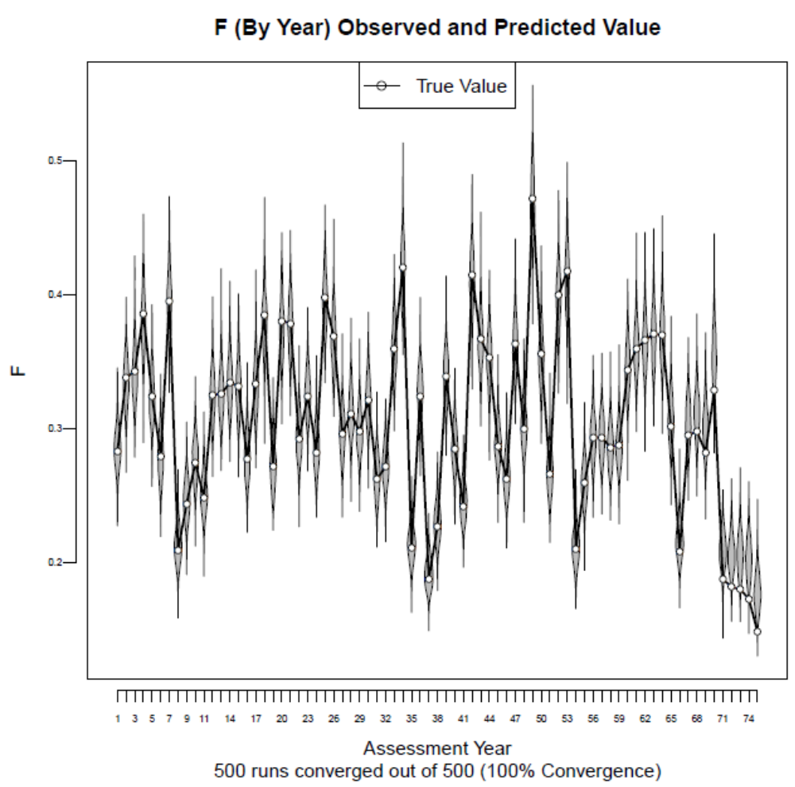
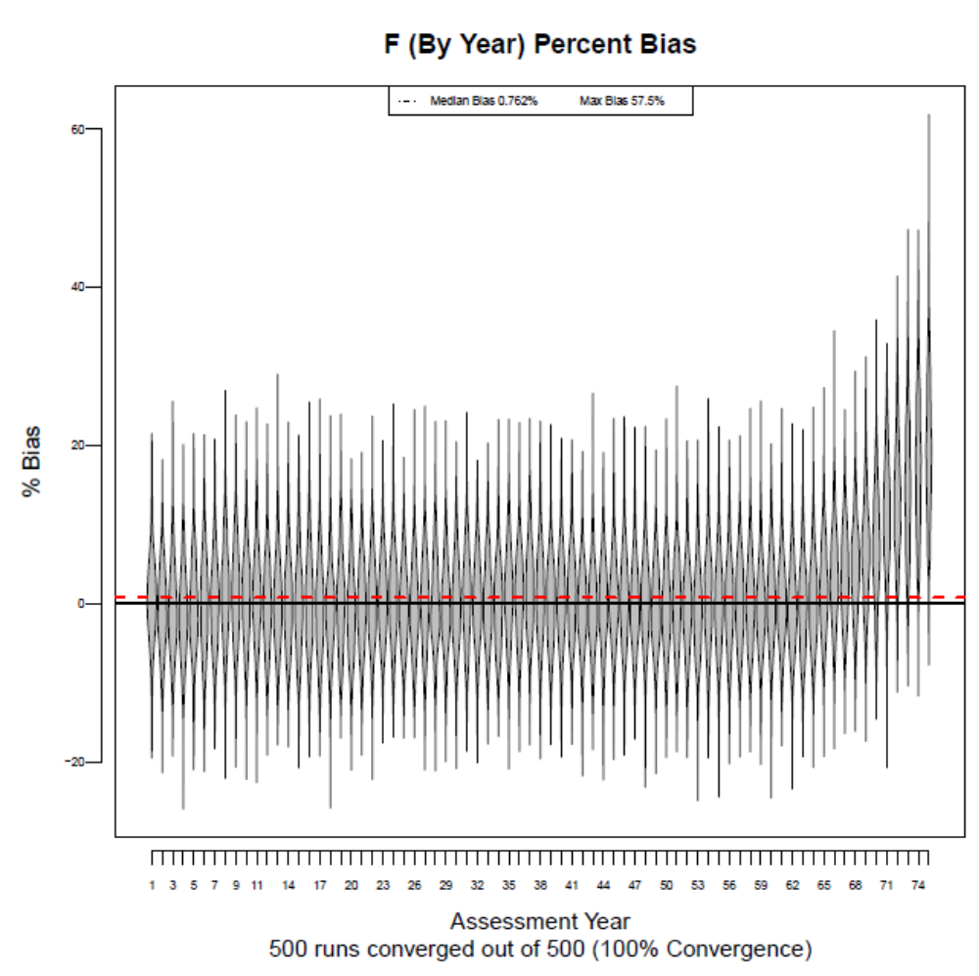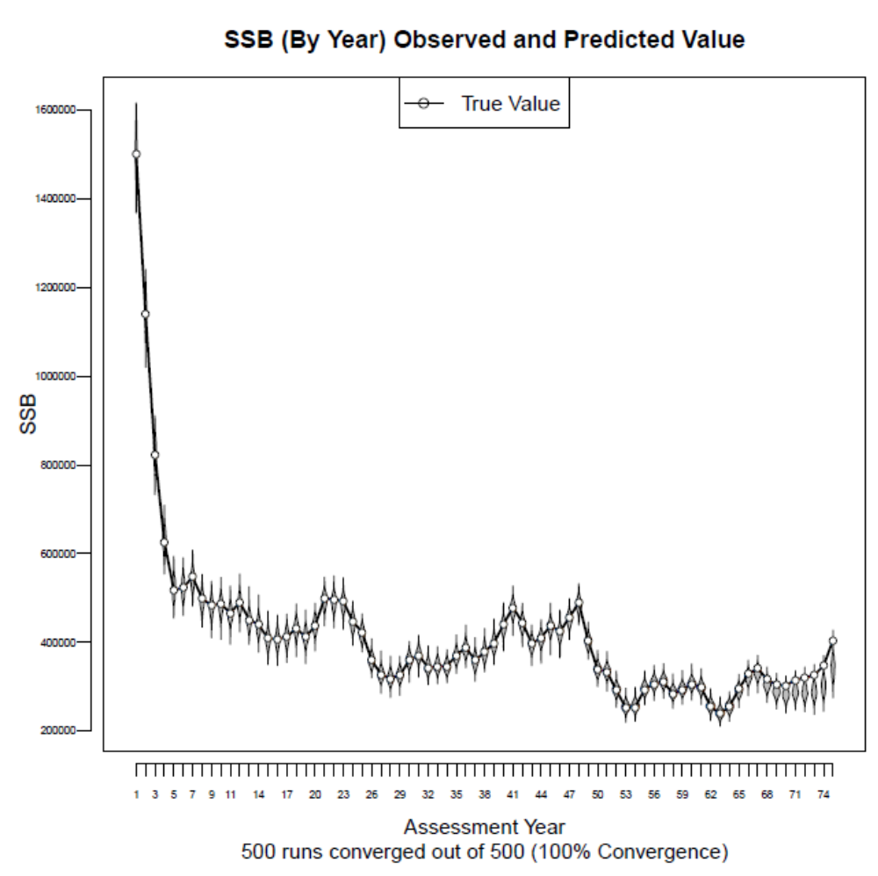

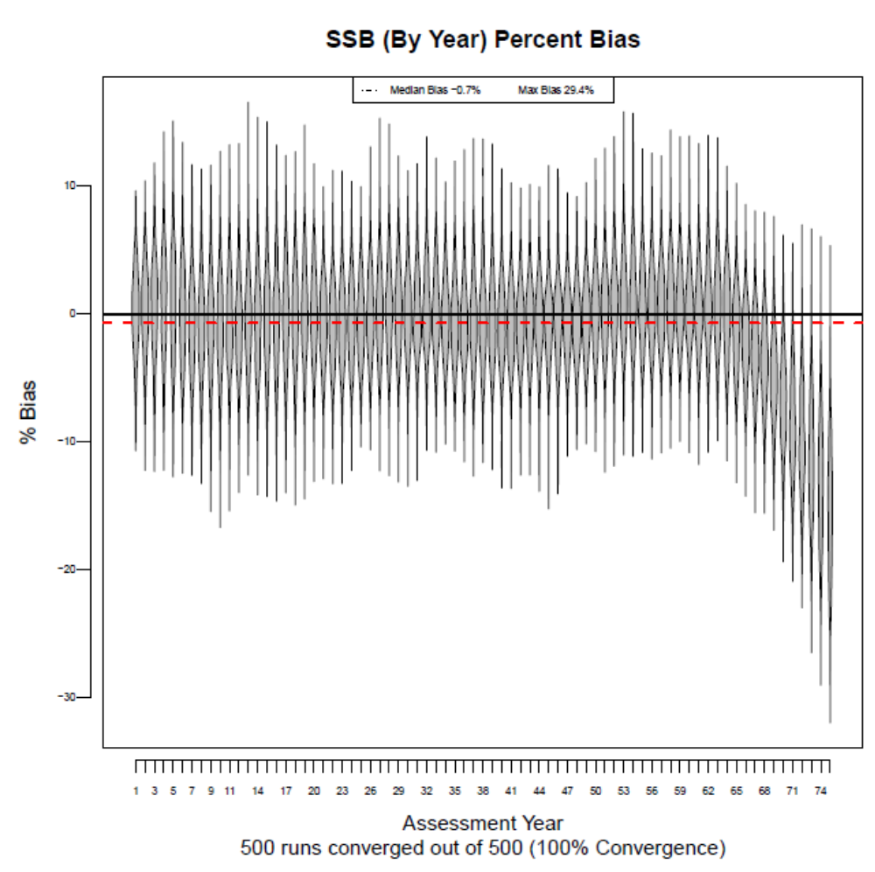

Figure 2: Distribution of F, F percent bias, distribution of SSB, and SSB bias, respectively, for the case with TAC_{Scalar}=1.25 and a constant TAC. 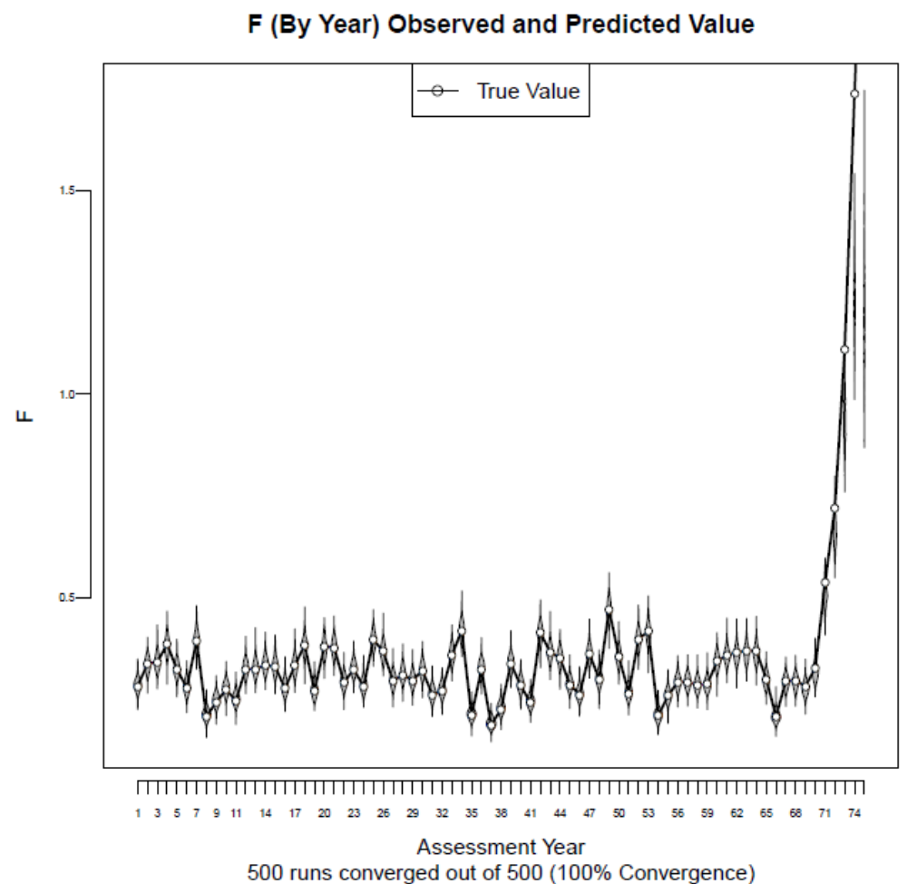 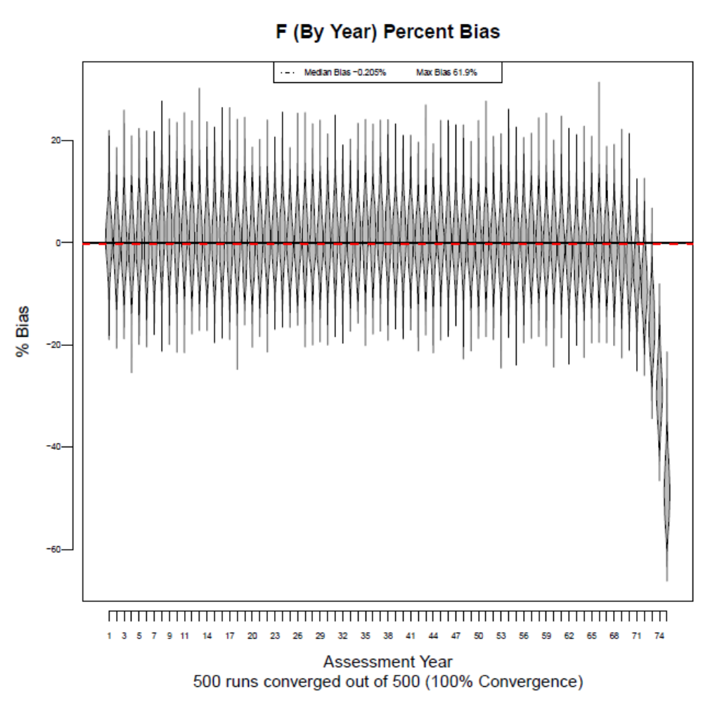 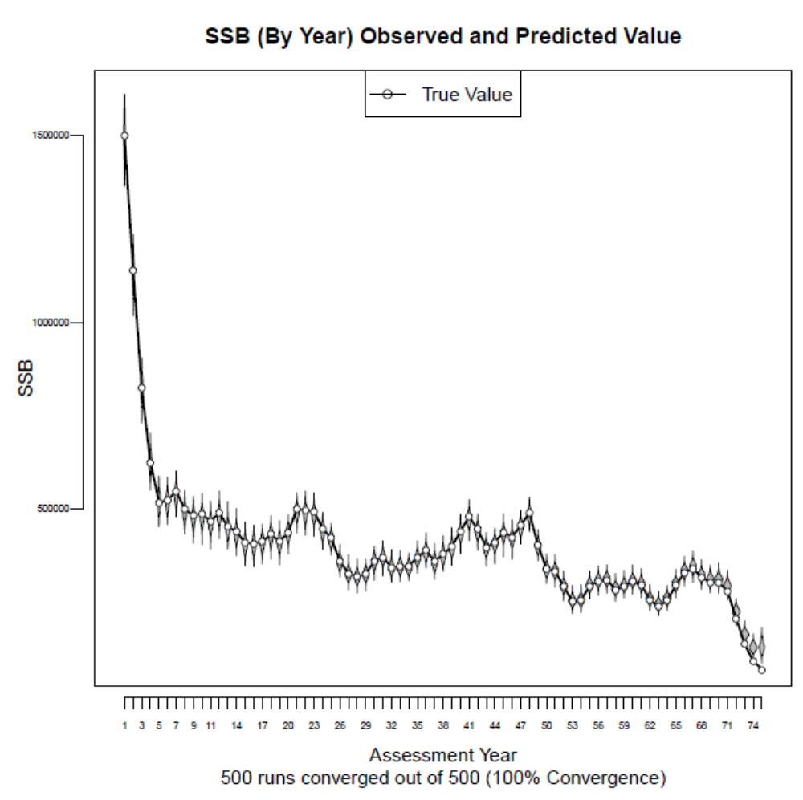 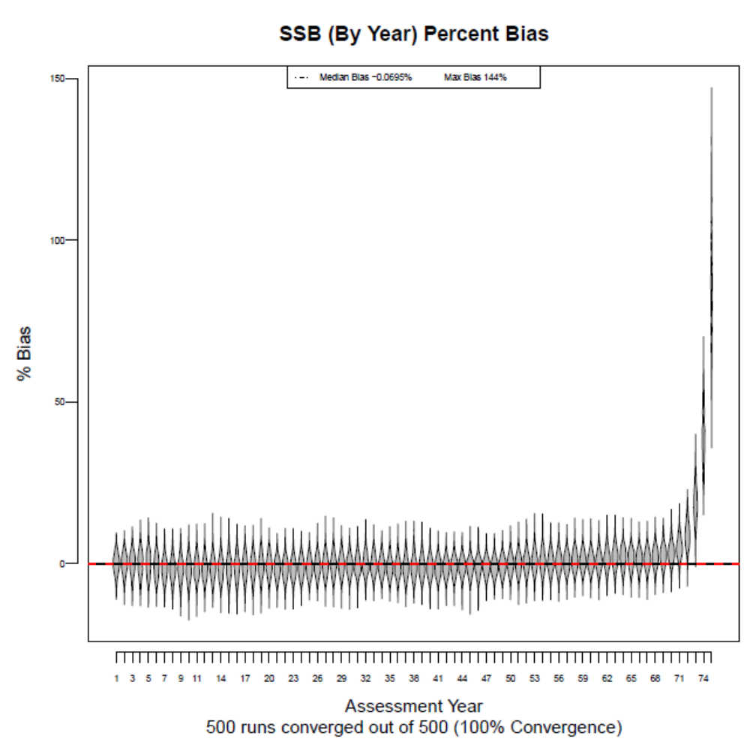

Figure 3: Distribution of F, F percent bias, distribution of SSB, and SSB bias, respectively, for the case with TAC_{Scalar}=1.0 and a constant TAC. 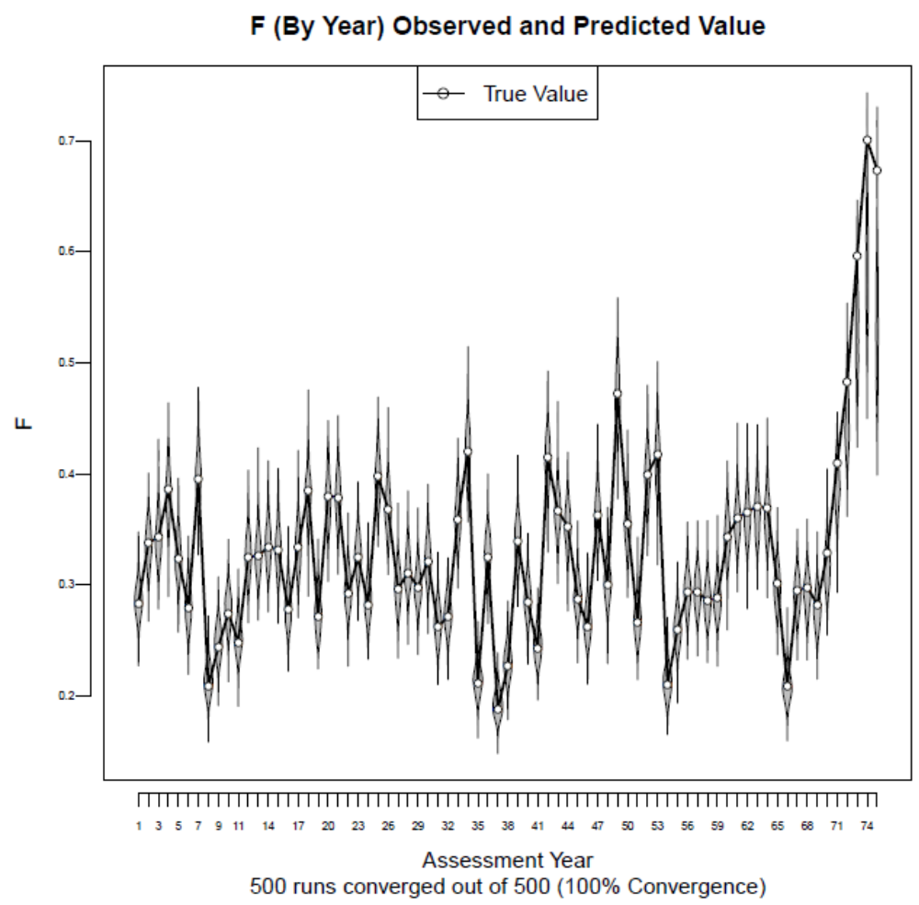 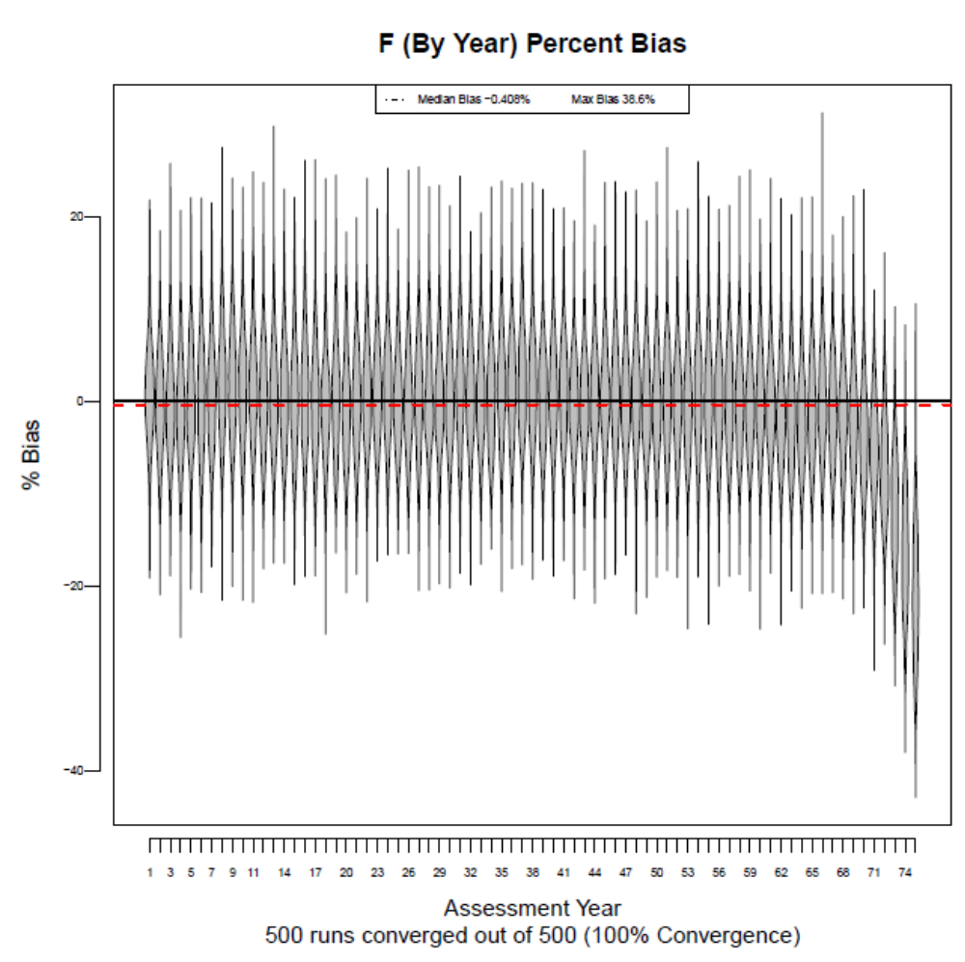 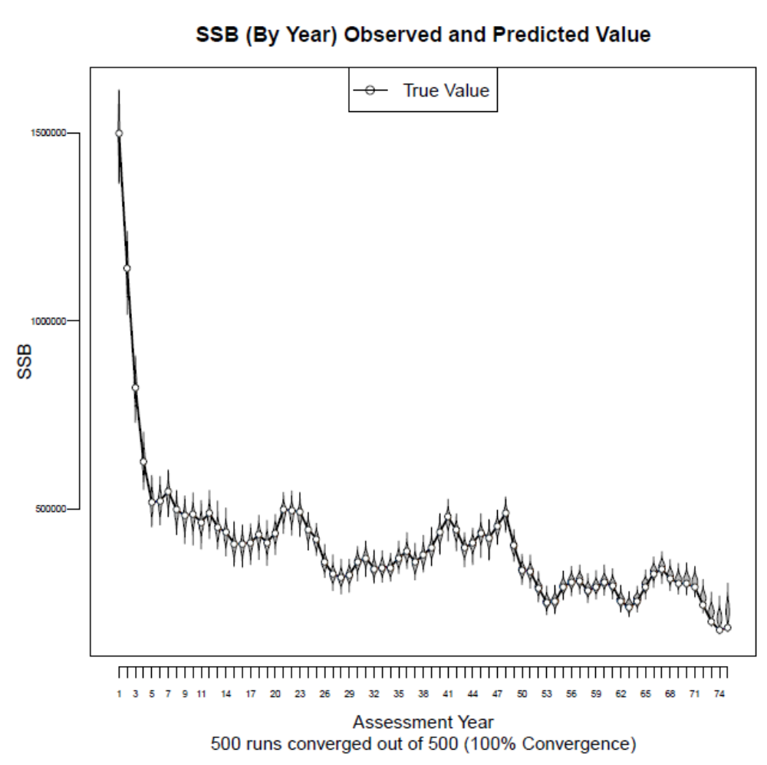 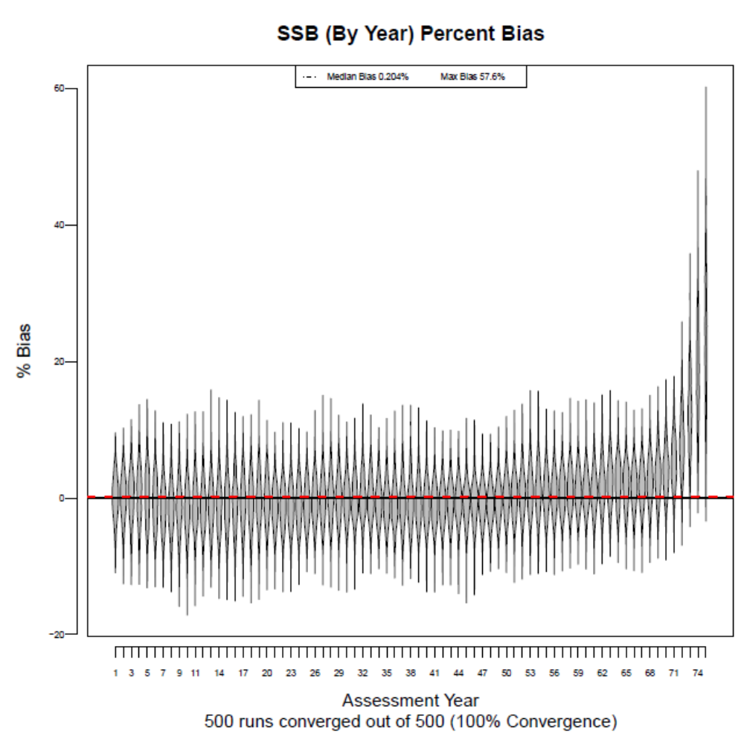

Figure 4: Distribution of F, F percent bias, distribution of SSB, and SSB bias, respectively, for the case with TAC_{Scalar}=1.0 and a dynamic TAC. 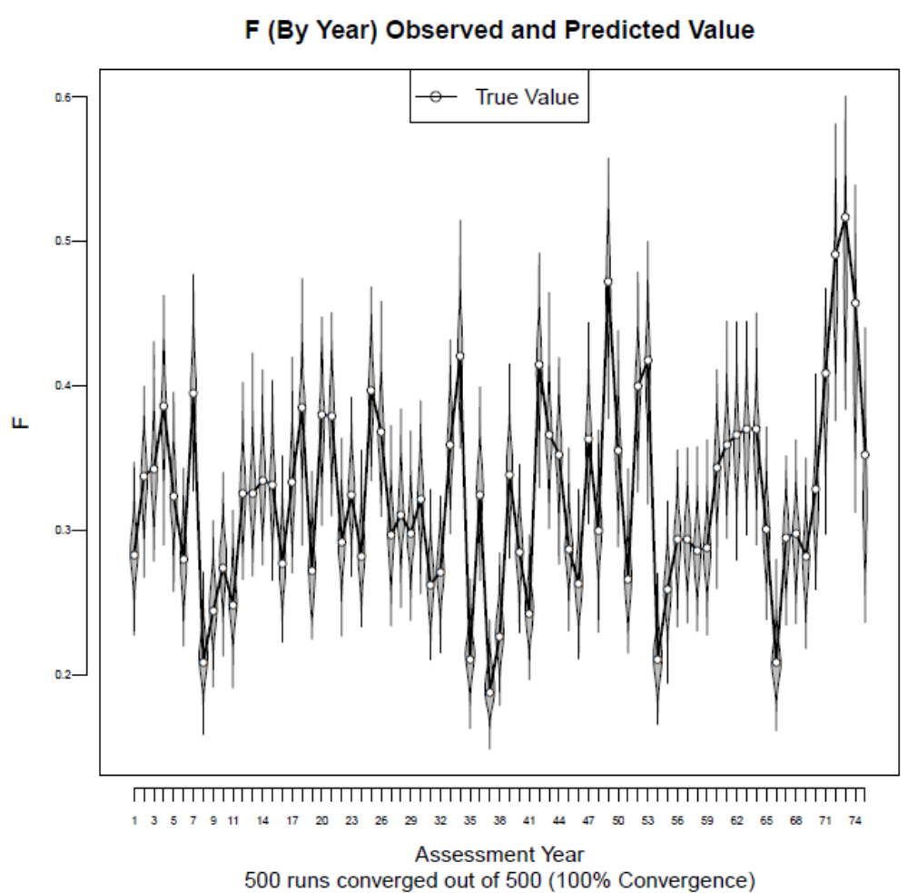 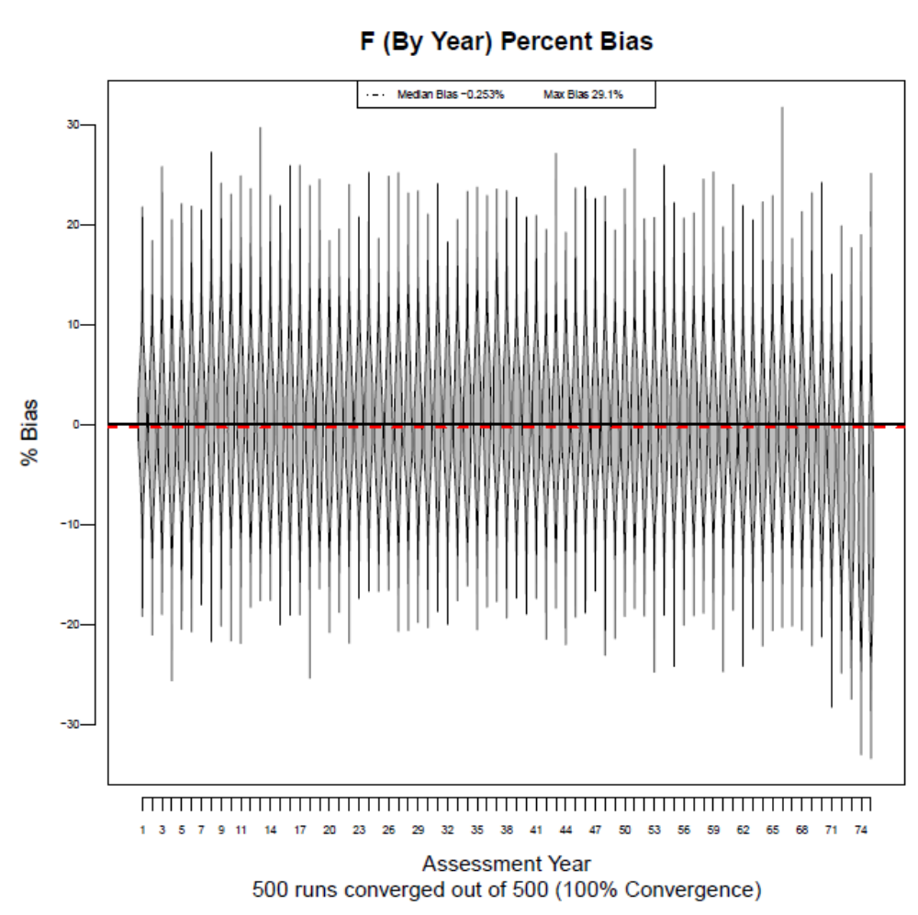 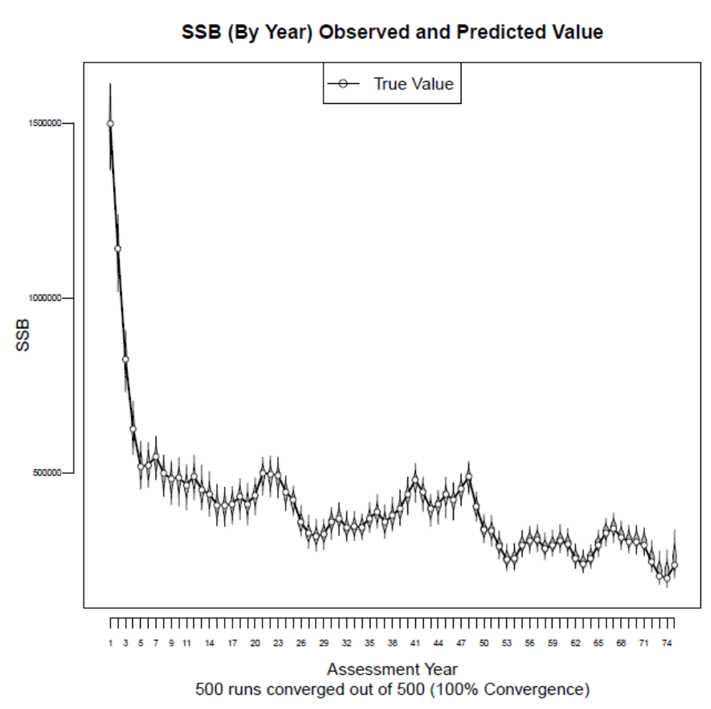 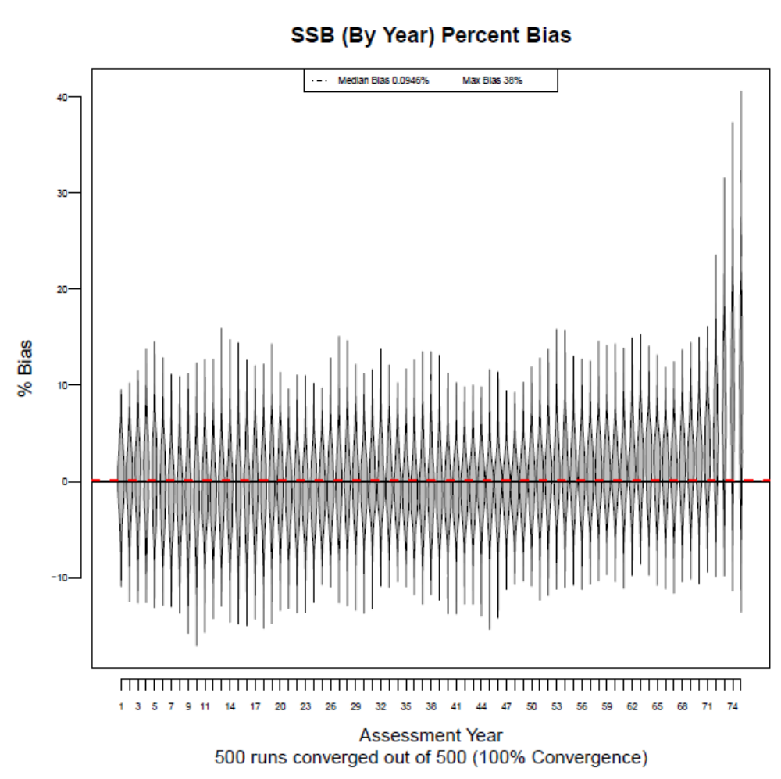

Figure 5: Distribution of F, F percent bias, distribution of SSB, and SSB bias, respectively, for the case with TAC_{Scalar}=0.5, a constant TAC, and assessment CV_{Survey}=0.1 (true simulation CV_{Survey}=0.25). This case needs further exploration as the results are not intuitive. 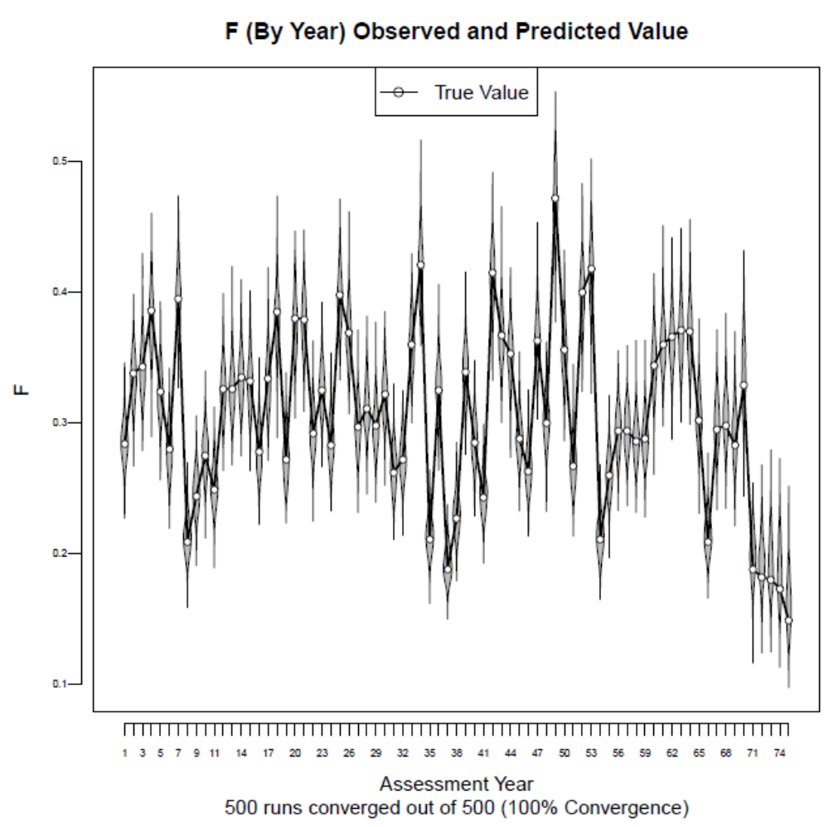 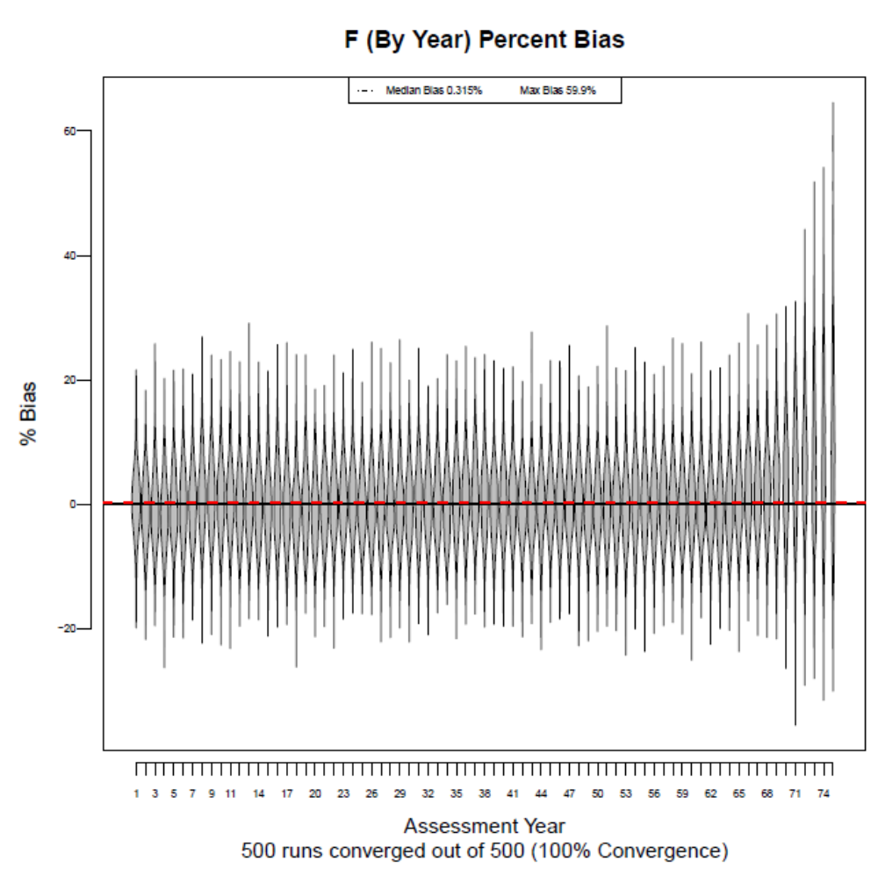 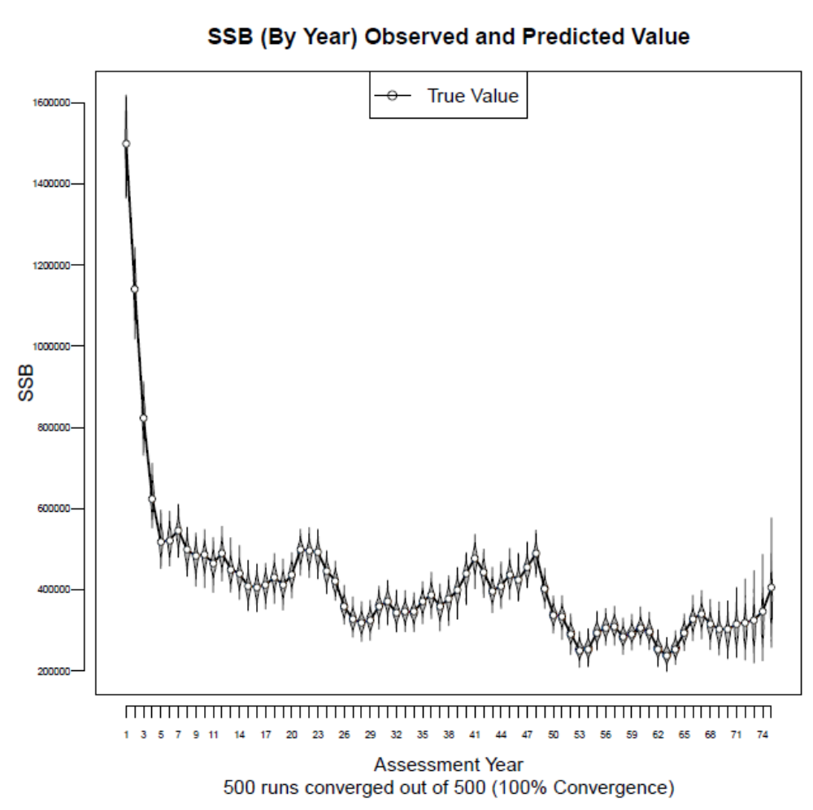 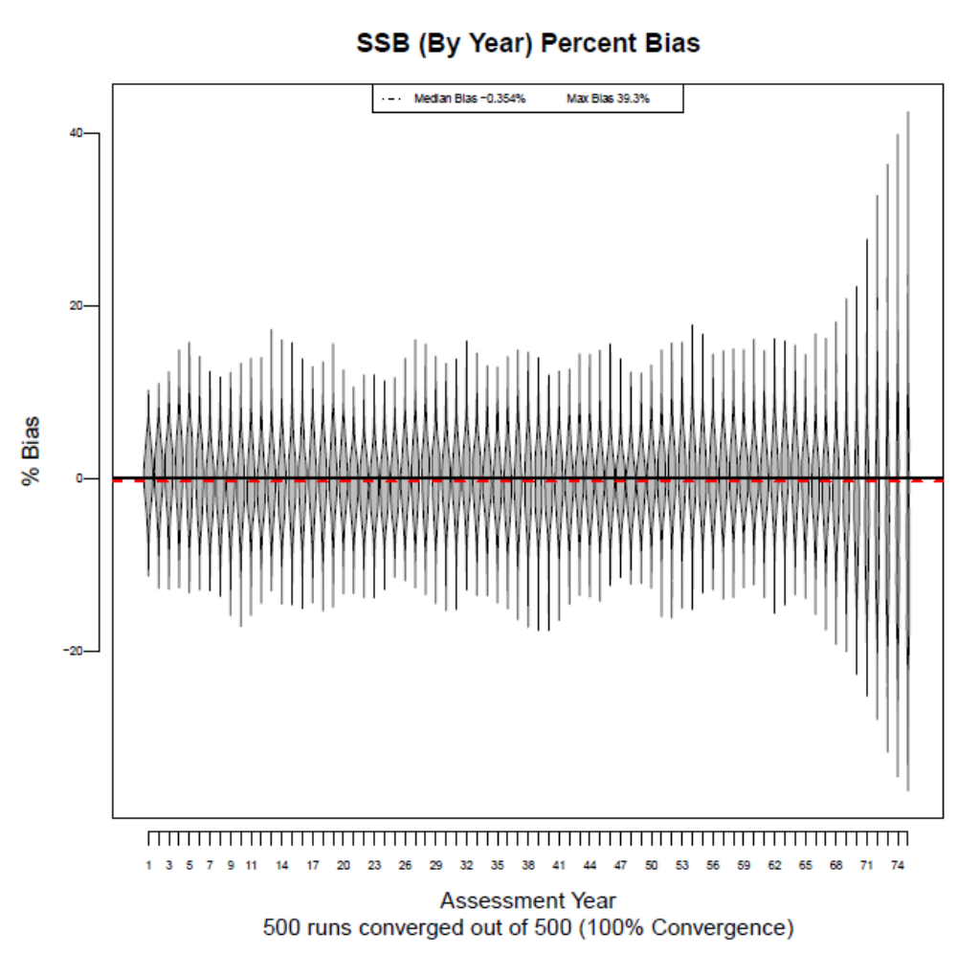

Figure 6: Distribution of F, F percent bias, distribution of SSB, and SSB bias, respectively, for the case with TAC_{Scalar}=0.5, a constant TAC, and CV_{Survey}=0.1. 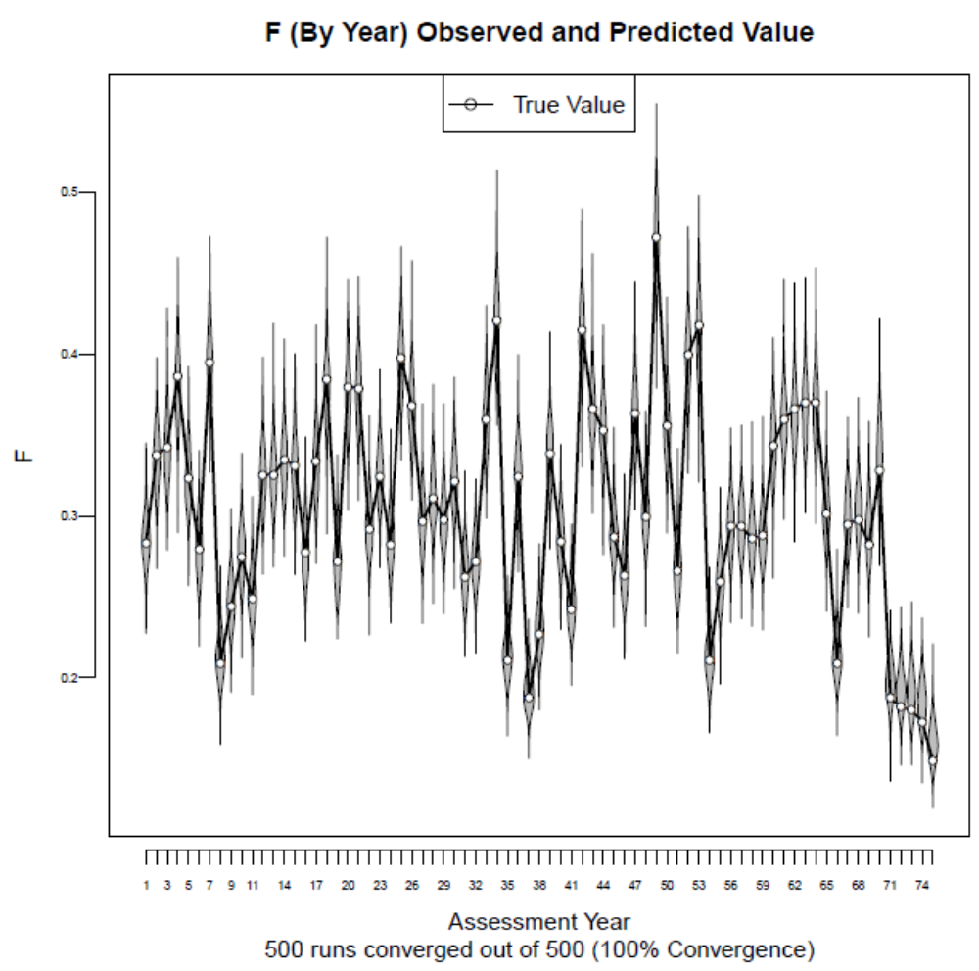 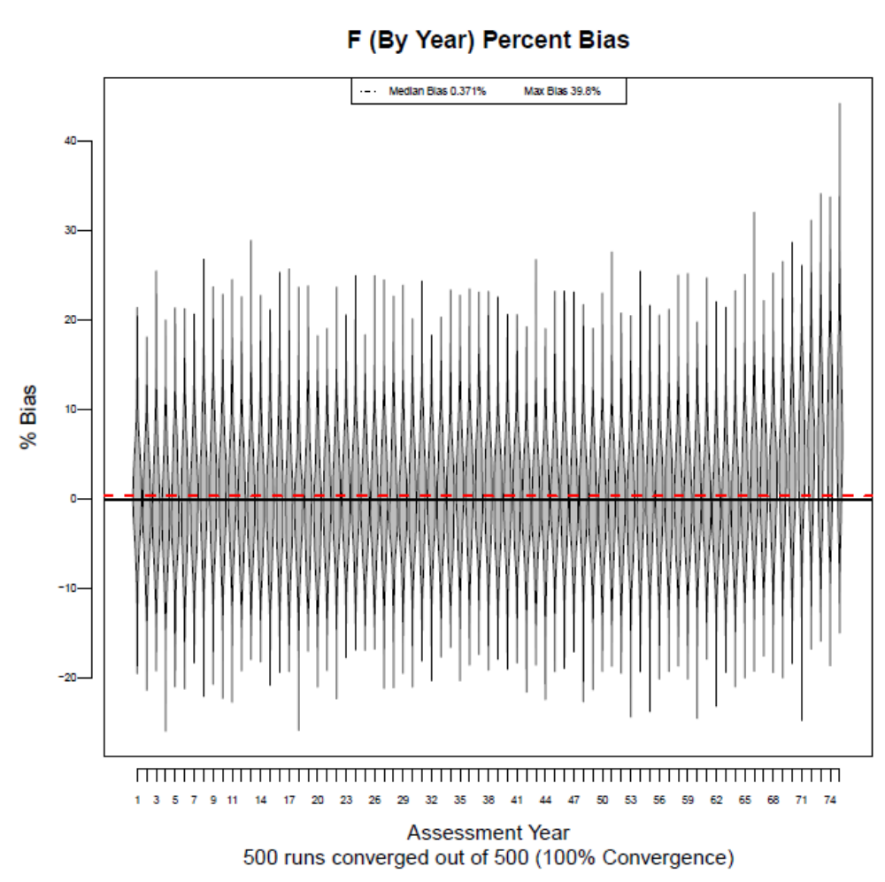 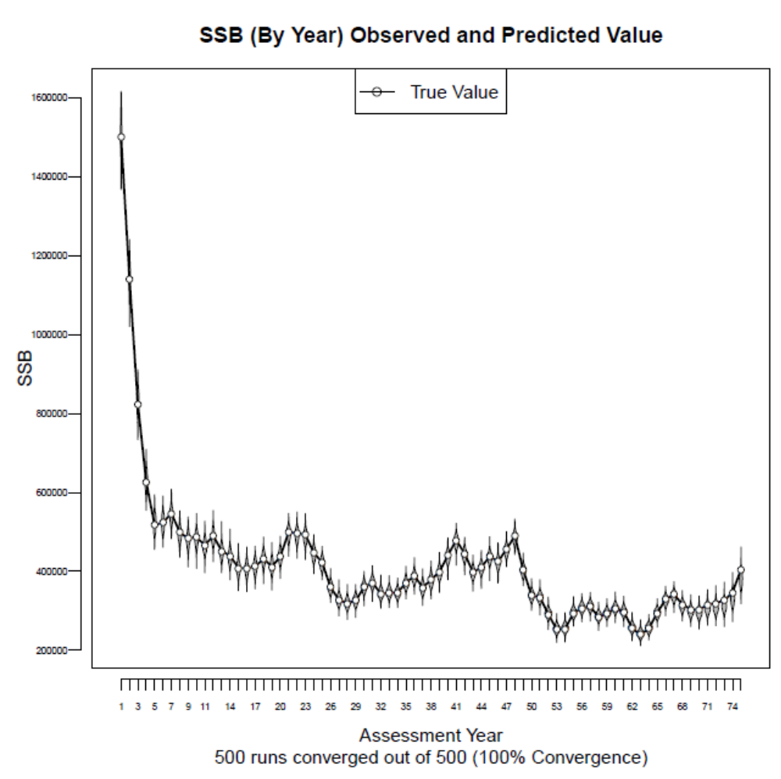 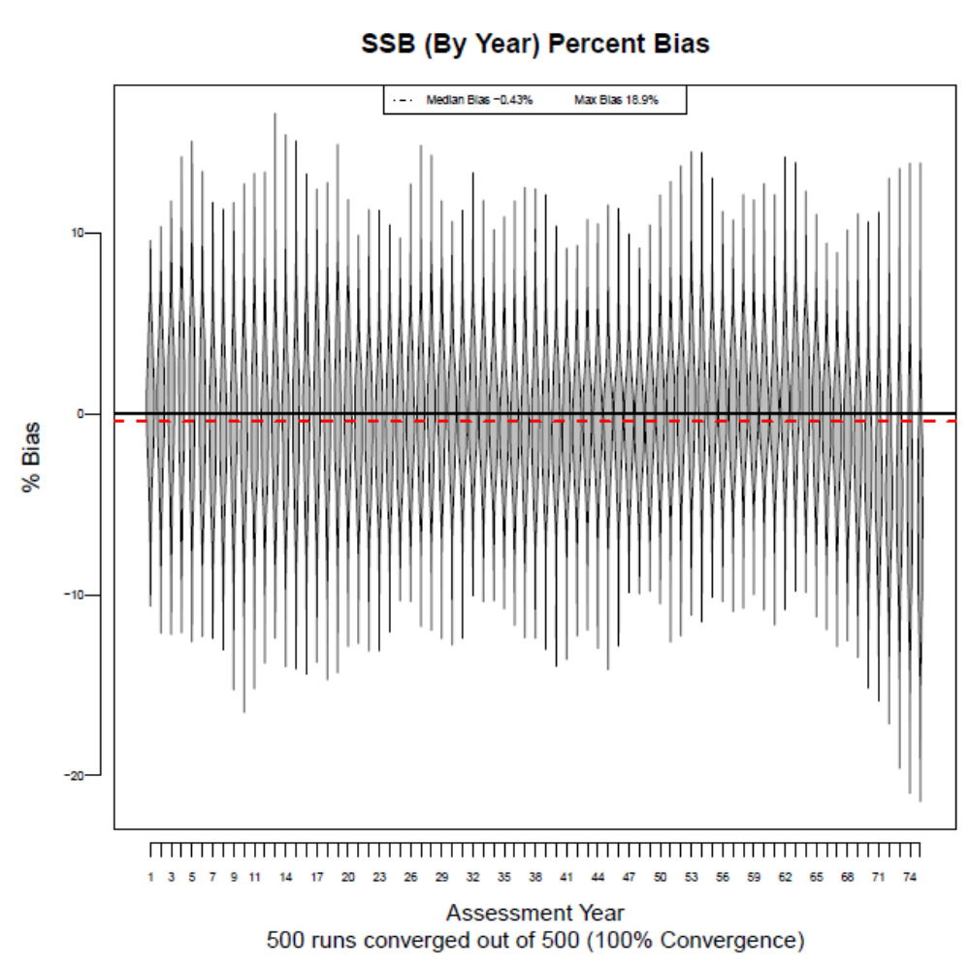

Figure 7: Distribution of F, F percent bias, distribution of SSB, and SSB bias, respectively, for the case with no TAC. In this case, F fluctuates about F_{MSY} for the entire timeseries. The results are meant as a base model against which to compare the bias levels of the assessments run following the implementation of TACs. 